POINT OF VIEW
LLM Tokenomics
The economics of tokens: how large language models are priced, why enterprise bills explode, and how to bring them under control

July 2026
Prices and benchmarks cited are indicative as of mid-2026. This market reprices monthly; treat figures as orders of magnitude, not quotes.

Contents
Contents 2
Executive summary 4
1. LLMs and tokens: how tokens are produced 5
1.1 The anatomy of an LLM 5
1.2 The four stages of a request 6
2. The pricing landscape: how LLMs are priced today 7
2.1 The five pricing models 7
2.2 Per-token list prices, mid-2026 8
2.3 LLMflation: the price trend underneath it all 9
3. Supply-side cost drivers: what a token actually costs 10
3.1 The four quantities that set the cost of a token 10
3.2 Training: compute, data and utilisation 10
3.3 Energy, data centres and operations 11
3.4 Inference COGS: memory bandwidth is the bottleneck 12
3.5 The stack a provider must recover 12
4. Proprietary vs open-source tokenomics 14
4.1 The DeepSeek shock and the repricing cascade 14
5. Why enterprise LLM bills become high 15
5.1 The agentic multiplier 15
5.2 What a workload actually costs 16
5.3 RAG adds spend in three places — and vector search is the small one 16
5.4 The reasoning tax and the long-context habit 16
5.5 Where the waste hides 17
6. Levers for enterprise cost optimisation 19
6.1 The big three, in practice 19
6.2 Fine-tuning and distillation 20
6.3 The self-hosting break-even 20
7. A FinOps framework for AI in the enterprise 21
7.1 The four governance moves that matter 21
7.2 The metrics that belong on the dashboard 22
7.3 Tooling and the operating model 22
8. Forward-looking trends and implications 24
8.1 Supply side: the forces and their trends to 2030 24
8.2 Quantifying the supply side: what makes a token 35× cheaper 24
8.3 Demand side: the forces and their trends to 2030 26
8.4 Quantifying the demand side: what makes volume 24× larger 27
8.5 Putting it together: the bill is a choice, not a forecast 29
8.6 The trajectory to 2030 30
8.7 Implications for suppliers 31
8.8 Implications for enterprise consumers 31
Appendix A. Glossary 33
Appendix B. Selected sources 35
Appendix C. Notes and references 36

Executive summary
Two things are simultaneously true about LLM economics in 2026, and understanding why is the key to this entire subject: the price of a unit of intelligence is collapsing at roughly 10× per year, and enterprise LLM bills are exploding — global enterprise API spend passed $8.4 B in 2025 and is on track to double in 2026. This is not a contradiction. It is a classic Jevons paradox: as tokens get cheaper, applications shift from single-shot chat to agentic workflows that consume 5–50× more tokens per task, and consumption growth outruns unit-price deflation.
On the supply side, the cost of producing a token is determined by physics and hardware economics: floating-point operations per token, memory bandwidth to read model weights, KV-cache memory to hold context, and the hourly cost of GPU infrastructure amortised across batched requests. A dense 70B-parameter model on an 8× H100 node produces output tokens at a marginal hardware cost on the order of $0.50–$1.50 per million tokens when well-batched. Everything a provider charges above that covers training amortisation, R&D, energy, idle capacity and margin. Proprietary vendors price on value; open-weight hosts price near marginal cost — which is why the same class of capability can differ 10× in price across providers.
On the demand side, enterprise bills are dominated by structural waste: studies estimate 40–60% of enterprise token budgets go to redundant context, repeated retrieval, retry storms and agent loops without budget constraints. Agents re-send accumulated context on every step, so a 20-step agent pays for its system prompt twenty times. Output tokens cost 3–8× input tokens, and reasoning models multiply output further.
The optimisation playbook is now well-established: meter first, then apply prompt caching (up to 90% off cached input), model routing (50–70% of requests can go to the cheapest tier), batch APIs (50% off), context engineering, and above ~$15–20K/month of steady spend, use distillation and self-hosting. Combined, teams report 60–80% reductions without capability loss.
Looking forward, per-unit-capability prices should keep falling 3–5× annually through 2027 before tapering; Gartner projects that inference on a trillion-parameter model will cost providers over 90% less in 2030 than in 2025. But agentic adoption is forecast to multiply token consumption up to 120× by 2030, so aggregate enterprise spend will rise. For suppliers, the mid-tier commoditises and pricing shifts toward outcome- and subscription-based models. For consumers, token-cost architecture becomes a permanent engineering discipline — as consequential as cloud FinOps was a decade ago.
Number | What it says | Where it comes from
~10× / year | Annual price decline for constant capability ("LLMflation") | a16z; Epoch AI price-trend data
$8.4B (2025) | Global enterprise LLM API spend — more than 2× 2024; doubling again in 2026 | Market analyses, mid-2026
5–30× | Token multiplier of agentic workloads vs a chat exchange | Gartner; production workloads
40–60% | Share of enterprise token spend that is removable waste | FinOps Foundation; deployment studies
100–500× | Quality-adjusted price spread, frontier vs commodity | Public list prices, mid-2026
60–80% | Bill reduction reported by teams applying the full lever | Production case reports
Table 1 · Six numbers that frame LLM tokenomics in 2026.

1. LLMs and tokens: how tokens are produced

1.1 The anatomy of an LLM
Before any pricing discussion makes sense, it helps to know what is physically happening when a model answers. An LLM is, mechanically, a next-token predictor: given everything it has seen so far, it computes a probability for every token in its vocabulary and emits one. Every capability that looks like reasoning or writing emerges from running that single step billions of times. Four parts of this machine matter commercially.
From text to numbers. A tokenizer splits text into tokens drawn from a fixed vocabulary of roughly 32,000–200,000 entries, and an embedding layer turns each token into a vector of numbers. Vocabulary design is a silent pricing variable: the same sentence can be 20% more tokens in one model family than another, and non-English languages often tokenize 2–3× less efficiently — the same document costs more to process in Hindi than in English.
The engine: transformer layers. The vectors then pass through a stack of dozens of identical transformer layers. Each layer does two things: attention, in which every token looks at every previous token to decide what matters (this is how the model uses context), and a feed-forward network that transforms the result. The learned numbers inside these layers are the parameters, or weights — 7 billion in a small model, hundreds of billions in a frontier one. Two consequences matter for cost: attention work grows with the square of context length, and generating each new token requires reading the weights from GPU memory.
The KV cache: attention's working memory. To avoid recomputing attention over the whole history for every new token, the serving stack caches each token's attention state — its keys and values — in GPU memory. This KV cache grows with context length and with every concurrent user, and it competes for the same memory that holds the weights. It is the physical reason long context costs extra, and the reason prompt caching can be discounted ~90%: a cached prefix's KV state is simply kept warm and reused.
Dense vs Mixture-of-Experts (MoE). A dense model activates every parameter for every token. An MoE model routes each token through a small subset of specialist 'experts' — a trillion-parameter model might activate only 30–40 billion parameters per token, with serving cost tracking the active fraction, not the headline size. This is one of the main reasons 2025–26 models got cheaper without getting worse.
Precision. Weights are stored as numbers at a chosen precision — 16-bit, 8-bit, or 4-bit floating point. Halving precision halves the bytes that must move through memory for every token, which (as Section 3 shows) roughly halves the marginal cost of decoding. Quantisation is the closest thing token economics has to a free lunch.
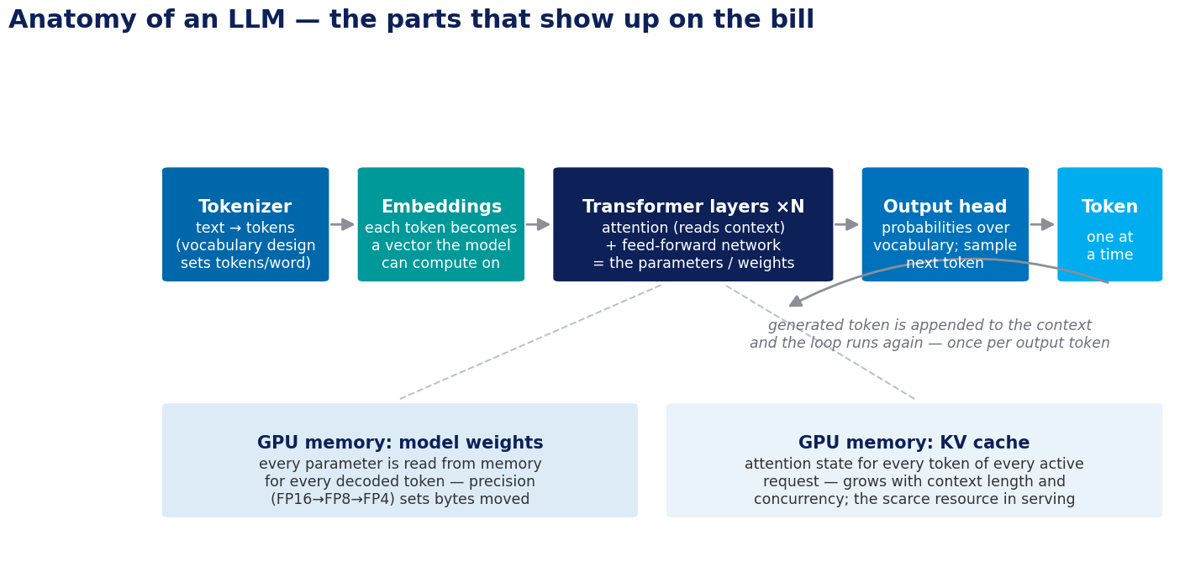
Figure 1 · Anatomy of an LLM. Every part of this machine reappears in Section 3 as a line item.
Concept | What it is | Why it shows up on the bill
Parameters & precision | The weights read on every decoded token; precision (FP16 → FP8 → FP4) sets bytes per weight | Bytes moved per token ≈ marginal cost of decoding
Context window | Everything the model attends to in a call: system prompt, history, retrieved documents, tool outputs | Re-sent and re-billed every turn; attention cost grows super-linearly
KV cache | GPU memory holding attention state for every token of every active sequence | The scarce serving resource; drives long-context surcharges and caching discounts
Attention | Each token reads all previous tokens to use context | Work scales with the square of context length
MoE / active parameters | Only a fraction of weights activate per token in MoE models | Serving cost tracks active, not total, parameters
Tokenizer & vocabulary | How text is split into billable units | Same content can differ ~20% in token count across model families
Table 2 · The cost-relevant anatomy. These six quantities generate every number in Section 3.

1.2 The four stages of a request
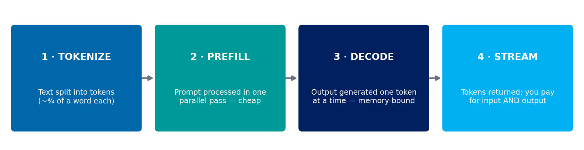
Every commercial conversation about LLM pricing eventually reduces to one unit: the token. A token is a fragment of text — roughly four characters, or about three-quarters of an English word. Models read and write the world in tokens, and providers meter and bill in tokens. To reason about cost, follow one request through the serving stack.
Figure 2 · The token pipeline. Prefill is parallel and cheap; decoding is sequential and expensive.
- Tokenize. The prompt is split into tokens by the model's tokenizer. Vocabulary design matters commercially: the same sentence can be 20% more tokens in one model family than another, which silently changes the bill.
- Prefill. The model processes the entire prompt in one parallel pass. Because all input tokens are computed together, prefill is compute-bound and extremely efficient — often 10–100× more tokens per GPU-second than decoding.
- Decode. Output is generated one token at a time. For each new token, the GPU must read every model weight from memory. Decoding is therefore memory-bandwidth-bound, not compute-bound — the arithmetic units sit mostly idle, starved by memory.
- Stream. Tokens are detokenized and returned. You pay for both directions: input tokens at the input rate, output tokens at the (much higher) output rate.
The first asymmetry
Output tokens are priced 3–8× higher than input tokens across virtually every provider. This is not marketing — prefill processes the whole prompt in one parallel pass, while decoding pays a full memory-bound pass per token. The same physics is what makes prompt caching honest: if the provider keeps your prompt's KV cache in memory, re-processing is nearly free, so cached input can be discounted ~90% and remain profitable.

2. The pricing landscape: how LLMs are priced today
The commercial menu now spans five distinct pricing models, usually layered on top of each other in a real enterprise deployment. Understanding which meter is running — per seat, per token, per call, per hour, or per training run — is the first step of any cost review.

2.1 The five pricing models
Model | Unit | Typical price | Where you meet it
Subscription | per seat / month | $20–100+ | ChatGPT Business (~$20/user/mo annual); Claude Team ($20 standard, $100 premium seat). Bundles UI, caps, admin, support — not a pure model price
Per-token API | per 1M tokens in/out | $0.06–$60 | The dominant developer tariff: every hosted API (OpenAI, Anthropic, Google, AWS Bedrock, open-weight hosts)
Per-request | per tool call / query | $2.50–$35 per 1,000 | Tool and retrieval surcharges: web search ~$10/1k calls; file search ~$2.50/1k; search grounding ~$35/1k prompts; rerank per search-unit
Compute-hour | per GPU-hour | $2.50–$80/hr | Dedicated endpoints and provisioned throughput: ~$2.50/hr (1× A100), ~$10/hr (1× H100), ~$80/hr (8× H100); Bedrock custom-model units
Fine-tuning | per hour or per token | ~$100/hr or ~$8/1M tok | Managed customisation: o4-mini-class training ~$100/hr; Bedrock Llama-class ~$8 per 1M training tokens + storage + hosting
Table 3 · The five commercial meters, with mid-2026 reference points.

2.2 Per-token list prices, mid-2026
Per-token pricing remains the centre of gravity. The table below shows indicative list prices per million tokens for representative tiers. These figures move monthly and are shown to make the structure of the market visible rather than as procurement data.
Model / tier | Input $/M | Output $/M | Notes
GPT-5 class (frontier) | ~$10 | ~$30 | Premium reasoning tier; o-series reasoning runs higher (~$15/$60) with hidden reasoning tokens
DeepSeek V4 (open) | <$0.05 | ~10–13× below frontier | Priced ~97% below GPT-5.5-class — the "DeepSeek shock" that triggered a global repricing cascade
Claude Opus 4.6 | $5 | $25 | Frontier; flat-rate long context
Claude Sonnet 4.6 | $3 | $15 | Workhorse tier; 1M context without surcharge
Gemini 3.1 Pro | ~$2 | ~$12 | Cheapest frontier-class (≤200K prompts; higher above)
Gemini 2.5 Flash | $0.15 | $0.60 | Value tier, 1M context
GPT mini / nano tiers | $0.10–0.75 | $0.40–4.50 | Ultra-budget proprietary; ~10–30% of flagship pricing
Llama-class 70–109B (hosted) | $0.06–0.60 | $0.30–0.90 | Cost-plus commodity hosting (DeepInfra, Together, Fireworks)
Small open models (7–8B) | from $0.06 | from $0.06 | Effectively free at enterprise scale
Table 4 · Indicative list prices per 1M tokens, standard serverless tiers, mid-2026.
Structural reading
Three features matter more than any single number. First, the frontier-to-commodity spread is roughly 100–500× — the widest quality-adjusted price dispersion of any input an enterprise buys. Second, every major provider now offers the same three discounts: ~90% off cached input, 50% off batch processing, and steep mini tiers; batch + caching together take effective cost to roughly 25% of on-demand rates before any engineering effort. Third, the moment an open-weight model matches a capability tier, that tier's price collapses to hosting economics — in weeks, not years.

2.3 LLMflation: the price trend underneath it all
For constant capability, inference prices have fallen roughly 10× per year since 2022 — faster than compute in the PC era or bandwidth in the dot-com era (a16z calls this "LLMflation"). GPT-4-level performance cost $20+ per million tokens in late 2022, roughly $2 by 2024, and $0.40–0.80 by early 2026, with economy tiers delivering near-GPT-4 quality at ~$0.10.
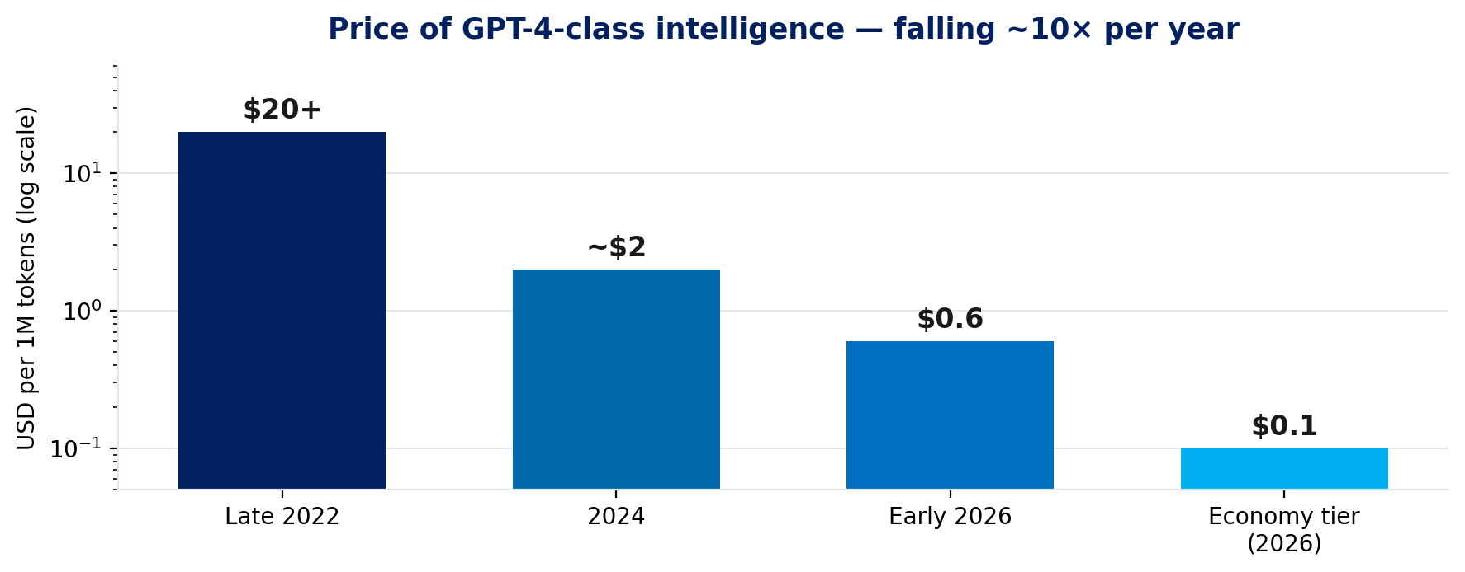
Figure 3 · The collapsing price of GPT-4-class intelligence (log scale).
The decline stacks four multiplicative layers: hardware (each GPU generation cuts cost per token 4–15×; Blackwell-class silicon demonstrates ~$0.02/M tokens on open 120B models), model architecture (MoE sparsity, distillation, FP8/FP4 quantisation), serving software (continuous batching, paged KV caches, speculative decoding — each worth 2–10× utilisation), and competition (open-weight releases put a hard ceiling on what any matched tier can charge).

3. Supply-side cost drivers: what a token actually costs
Every price on an API page is a markup over a marginal cost that can be derived from four quantities: arithmetic operations per token, memory bandwidth, memory capacity, and the hourly cost of hardware. This section builds the cost stack from first principles — training, post-training, and inference.
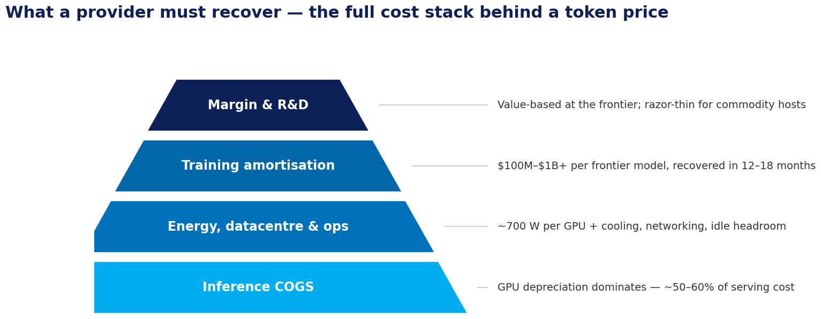
Figure 4 · The supplier cost stack. Token prices are a markup over a physical floor.

3.1 The four quantities that set the cost of a token
Strip away branding and every supplier's unit economics reduce to four measurable quantities. Everything else in this section is arithmetic on top of them.
Quantity | What it measures | What it drives
FLOPs per token | Arithmetic operations needed to process or generate one token | Training cost; prefill cost
Bytes per token | Memory traffic: weights and KV state read per decoded token | Decode cost — the dominant variable cost
KV memory per request | GPU memory consumed by context, per concurrent user | Feasible batch size; long-context surcharges
$ per GPU-hour | Fully loaded hardware cost: capex depreciation, energy, facility | The price of everything above
Table 5 · The four physical quantities behind every token price.
The structure of the section follows the money: training (a fixed cost, amortised into every token a proprietary vendor sells), then energy and data-centre operations (semi-fixed), then inference COGS (the true variable cost), and finally the full stack a provider must recover.

3.2 Training: compute, data and utilisation
The compute rule. A useful approximation for dense transformer training is total FLOPs ≈ 6 × N × D, where N is parameter count and D is training tokens. Chinchilla's landmark result showed many large models were undertrained: a 70B model trained on 4× more data can beat much larger models at the same compute budget. Training cost is therefore a design choice, not just a size choice.
Utilisation (MFU). Model FLOPs Utilisation — achieved throughput as a share of theoretical peak — is economically critical. Reported campaigns range from ~21% (GPT-3 on V100) to 44–56% (TPU v4). A cluster at 50% MFU is roughly twice as cost-effective as one at 25% for the same silicon.
Scale. PaLM-class training used 6,144 TPU v4 chips; at ~$3.22 per chip-hour that is roughly $20,000 per hour of rented accelerator time, or $14–28M for a 30–60-day run — before data pipelines, storage, networking and people. Frontier runs today are $100M–$1B+, and must be recovered during a competitive half-life of 12–18 months.

3.3 Energy, data centres and operations
Every token is, at bottom, converted electricity. A single H100-class GPU draws ~700 W under load; an 8-GPU inference server draws roughly 10 kW once CPUs, memory and networking are counted. Data-centre overhead multiplies that again: cooling and facility loads add 20–40% (a Power Usage Effectiveness, or PUE, of 1.2–1.4). A 1,000-GPU cluster therefore draws ~1.7–1.8 MW continuously — $90,000–$250,000 per month of electricity at $0.07–$0.20 per kWh, before a single salary or lease payment.
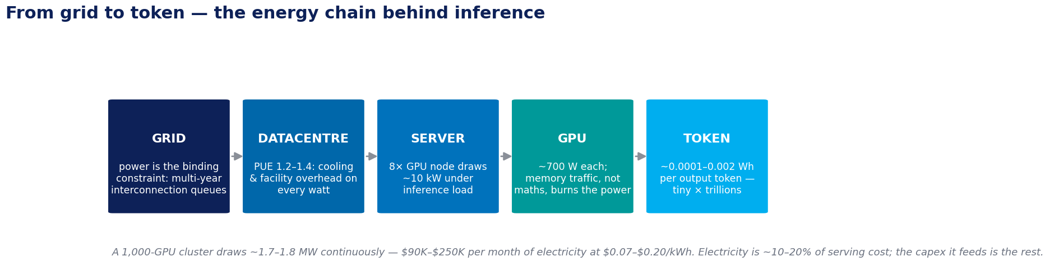
Figure 5 · The energy chain. Each stage adds overhead; the grid connection is now the scarcest link.
Per token, energy is small; in aggregate, it is decisive. Measured inference energy runs ~0.0001–0.002 Wh per output token depending on model size — fractions of a cent per million tokens. Electricity is therefore only ~10–20% of serving cost; GPU depreciation dominates. But energy determines where and whether capacity can be built at all, and idle GPUs burn depreciation whether or not they serve tokens — which is why utilisation, not wattage, is the number operators obsess over.
Power is the binding constraint on supply. Grid interconnection queues in the US now exceed 2,600 GW of waiting projects with multi-year delays, and roughly half of planned AI data centres face connection slippage. The response is vertical: Microsoft signed a ~20-year PPA to restart Three Mile Island Unit 1 (835 MW); AWS contracted 1.92 GW from the Susquehanna nuclear plant; Google ordered a fleet of small modular reactors for the 2030s. When suppliers lock in decade-long power contracts to serve tokens, energy stops being an operating detail and becomes a strategic moat — and a floor under long-run token prices.
Operations round out the stack. Liquid cooling is displacing air as rack densities pass 100 kW; high-bandwidth networking (NVLink, InfiniBand) is required to serve large models across GPUs; and a 24×7 site needs staff, security, spares and redundancy. None of these scale down per token the way silicon does — they are the sticky part of the cost base.
Unit | Typical draw / figure | Cost consequence
One GPU (H100-class) | ~700 W under load | ~$450–$1,200/year of electricity per GPU
8-GPU server | ~10 kW | The unit in which inference capacity is rented (~$20/hr, 2026)
1,000-GPU cluster | ~1.7–1.8 MW (PUE 1.2–1.4) | $90K–$250K/month electricity at $0.07–$0.20/kWh
1M output tokens | ~0.1–2 kWh of energy | Cents — electricity is ~10–20% of serving cost; capex is the rest
Table 6 · The power arithmetic of inference, 2026.

3.4 Inference COGS: memory bandwidth is the bottleneck
During decoding, the GPU must read every model weight from memory for every generated token. A 70B model at 16-bit precision is 140 GB of weights; against ~3.35 TB/s of H100 HBM bandwidth, an unbatched request can generate at most ~24 tokens per second — the arithmetic units sit idle, starved by memory.
Batching changes everything. If 32 requests are processed together, weights are read once per forward pass and reused across all 32 sequences: per-token cost drops ~85% for ~20% added latency. Continuous batching (vLLM-style) pushes batch sizes to 64–512 and makes the GPU compute-saturated — the regime where expensive hardware earns its price. Serving cost is overwhelmingly a function of achieved batch size and utilisation.
The KV-cache tax. Long contexts consume prefill compute and squeeze the KV cache, shrinking the feasible batch size for everyone sharing the GPU. That is the physical reason providers surcharge long context — and why "stuff everything into the context window" is the most expensive habit in enterprise usage.
Speed costs money non-linearly. Epoch AI's inference-economics model shows that best-possible latency costs roughly 3× the minimum achievable cost per token, because faster serving needs more parallelism and pays network-latency overheads. Relaxing latency SLAs (batch lanes, async agents) recovers most of that 3×.

Worked example — the bottom-up floor
Rent an 8× H100 node at ~$20/hour (2026 cloud rates). Assume a well-batched dense 70B model sustaining ~5,000 output tokens/second across the node. Cost per million output tokens = $20 ÷ (5,000 × 3,600) × 1,000,000 ≈ $1.11. Benchmarks corroborate the order of magnitude — and NVIDIA's Blackwell platform pushes the floor toward $0.02/M on open 120B-class models. When an open-weight host charges $0.06–$0.90 per million tokens, that is cost-plus pricing on exactly this arithmetic. When a frontier API charges $10–25 per million output tokens, the difference is the rest of the cost stack — plus pricing power.

3.5 The stack a provider must recover
Cost component | Nature | Share of unit economics
GPU capex / depreciation | Fixed; amortised over ~3–5-year useful life; dominated by utilisation achieved | Largest single item (~50–60% of serving cost)
Energy & datacentre | ~700W per GPU plus cooling and facility overhead | ~10–20% of serving cost
Networking / interconnect | NVLink/InfiniBand for parallelism; all-reduce latency taxes fast decoding | Grows with model size and speed targets
Training amortisation | $100M–$1B+ per frontier model over a 12–18-month half-life | Priced into proprietary margins; absent for open-weight hosts
R&D, safety, data, talent | Ongoing frontier-lab overhead, incl. increasingly formal data licensing | Proprietary only
Idle / peak capacity | Latency SLAs force headroom; off-peak capacity still depreciates | Why batch APIs are 50% off — they monetise idle capacity
Margin | Value-based at the frontier; razor-thin for commodity hosting | The strategic variable
Table 7 · The full supplier cost stack.

What to watch on the supply side
Every layer of this cost stack is in motion: Rubin-class silicon and inference ASICs attack COGS, HBM4 attacks the memory bottleneck, and nuclear-backed power deals attack the energy line. Section 8.1 details the trends that will reprice this stack through 2030.

4. Proprietary vs open-source tokenomics
Proprietary APIs and open-weight models are not two prices for the same product — they are two different businesses. Understanding the difference explains almost all of the 10× price dispersion within a capability class.
Dimension | Proprietary frontier APIs | Open-weight models
What you pay for | Capability + training amortisation + R&D + margin | Hosting efficiency only — the artifact is free
Pricing logic | Value-based; price ladders (frontier / mid / nano) are price discrimination as much as cost | Cost-plus; competition drives price toward marginal serving cost
Training cost recovery | $100M–$1B+ per model, recovered over a 12–18-month competitive half-life | None — hosts bear no training cost and serve identical artifacts
Same model across hosts | Single vendor | Same weights vary ~20% in price between hosts on operational efficiency alone
Licensing | Contract terms | Apache-2.0 (fully open, e.g. Mistral 7B) to community licences with thresholds (Llama: extra licence >700M MAU)
When it wins | Frontier reliability, agentic robustness, integrated tooling, hard tail of tasks | Routine volume, cost control, data residency, portability and leverage
Table 8 · Two different businesses, two different prices.

4.1 The DeepSeek shock and the repricing cascade
DeepSeek's V3/R1 releases in 2025 and V4 in 2026 — priced roughly 90–97% below Western frontier equivalents while matching them on many agentic benchmarks — demonstrated that the price ceiling collapses in weeks once a tier is matched. Frontier vendors responded not with headline price cuts but with cheaper mid-tiers and aggressive caching discounts, defending frontier margin while ceding the mid-market.
Signal | Value | Implication
Frontier premium over commodity | 100–500× | The widest price spread of any enterprise input — routing decisions carry enormous leverage
DeepSeek V4 vs GPT-5.5-class list price | ~97% lower | Open-weight pricing is now an anchor for every negotiation
Frontier capability half-life | 6–12 months | Capability commanding $25/M output today is matched by an open model within a year, then reprices to hosting economics
Same open model across hosts | ~20% spread | Even within open hosting, operational efficiency is worth shopping for
Table 9 · The open-weight effect in four numbers.
Bottom line
Open weights stopped being the budget alternative in 2026 and became the default substrate for a widening set of routine workloads. The frontier premium survives but its scope narrows to what open models cannot yet do: agentic reliability, long-horizon tasks, and integrated tooling.

5. Why enterprise LLM bills become high
If unit prices fell ~80% between 2025 and 2026, why did enterprise spend double? Because bills are consumption × price, and consumption is exploding faster than price is falling — amplified by structural waste that most organisations do not yet measure. 85% of organisations misestimate AI costs by more than 10% (nearly a quarter by 50%+), and 79% report cost overruns in the past twelve months.
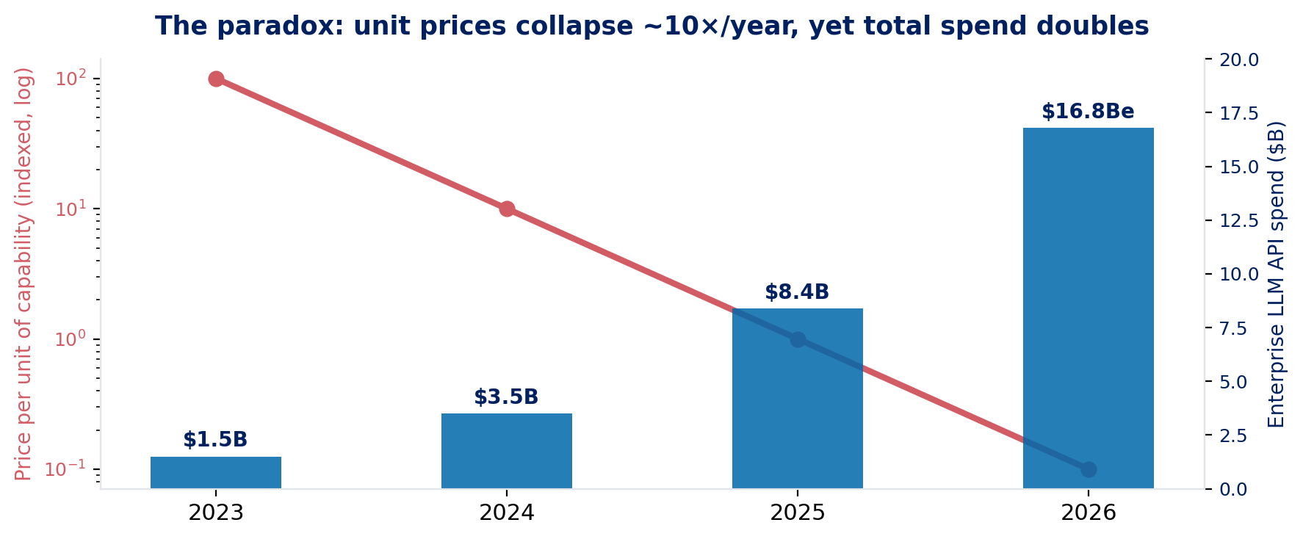
Figure 6 · Prices collapse, spend doubles: the consumption effect dominates.

5.1 The agentic multiplier
Agents are the dominant driver. A chatbot exchange is one call; an agent runs a loop — plan, call tools, read files, validate, retry — and each step re-sends the entire accumulated context. By step 20, you have paid for the same system prompt and history twenty times, and the context has grown with every step, so cost per task grows super-linearly with loop length. Measured agentic workloads consume 5–30× (some estimates 50×) the tokens of an equivalent chat interaction.
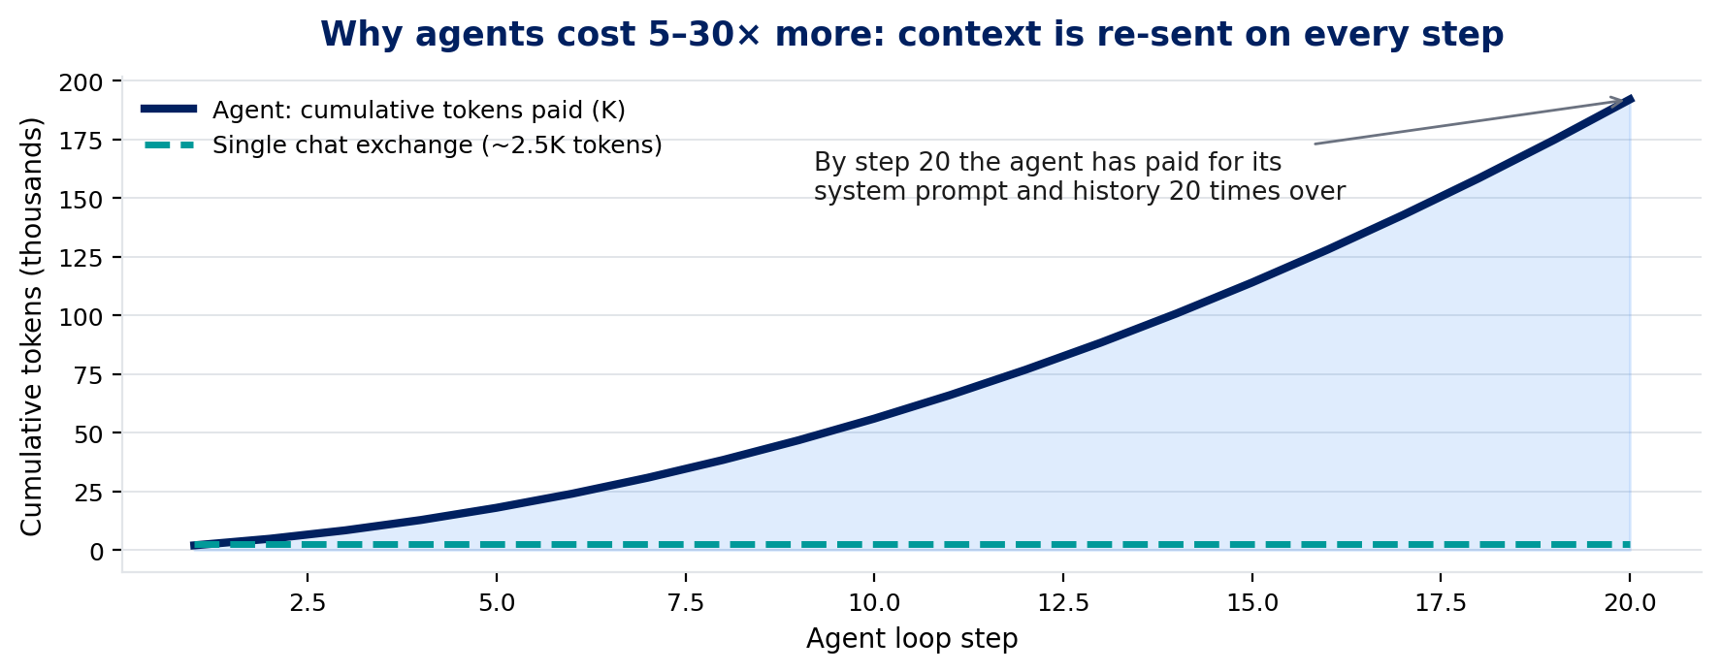
Figure 7 · Cumulative tokens paid across a 20-step agent loop vs a single chat exchange.

5.2 What a workload actually costs
Straight token arithmetic at list prices makes the drivers vivid. Two request shapes, 100,000 requests per month, no discounts, tools or vector costs:
Scenario (100k req/mo) | Request shape | Flagship API | Mid tier | Value tier
Lean assistant | 2,000 in + 500 out | ~$1,250 | ~$650 | ~$185
RAG-heavy assistant | 5,000 in + 700 out | ~$2,300 | ~$1,250 | ~$325
Table 10 · The gap between a lean and a RAG-heavy workload can rival the gap between providers.

Change on every request | Tokens | Adds per month
More input (prompt bloat, history carry-over) | +1,000 | ≈ +$250
More retrieved RAG context | +3,000 | ≈ +$750
More output (verbose responses) | +500 | ≈ +$750
Regional processing / residency premium | +10% on bill | ≈ +$125
Table 11 · Sensitivity on the flagship-API lean workload above (100k requests/month, list prices).

5.3 RAG adds spend in three places — and vector search is the small one
Retrieval-augmented generation bills you three times: retrieved passages inflate prompt tokens; embedding and indexing are metered; and the vector store itself charges for storage and queries. The public math is lopsided: querying a 50 GB vector namespace 100,000 times costs on the order of $80–90, while adding 3,000 retrieved tokens to the same 100,000 flagship-API requests adds ~$750. In most enterprise RAG systems the dominant cost is not vector search — it is the extra model context. Optimise retrieval precision and context compression before shaving vector-database pennies.

5.4 The reasoning tax and the long-context habit
The third structural driver, after agents and RAG, is the migration of traffic to reasoning models — models that generate an internal chain of thought before writing their visible answer. Those thinking tokens are billed at the full output rate but never appear in the response. A single hard query can generate ~10,000 hidden reasoning tokens: at $30 per million output tokens, that is $0.30 of invisible spend wrapped around a visible answer worth $0.006. Across enterprise deployments, reasoning tiers inflate effective output cost 3–10× versus the apparent per-token price.
The tiering is steep and easy to misuse. Providers now ship the same reasoning capability at ~10× price separation between standard and pro tiers, plus effort knobs (low/medium/high) that change hidden token volume several-fold. The failure mode is defaulting all traffic to a high-effort reasoning tier because it benchmarks best; the discipline is routing only genuinely hard steps — planning, verification, novel synthesis — to reasoning models, at the lowest effort that passes evaluation. Batch lanes apply their 50% discount to reasoning tokens too, which makes offline reasoning workloads half price.
The long-context habit compounds it. Million-token context windows invite teams to stuff entire repositories and document sets into every call. Input is billed linearly, but the physics is worse than linear: long contexts consume prefill compute, squeeze the shared KV cache, and trigger long-context surcharges above provider thresholds. Retrieval precision and context compression nearly always beat brute-force stuffing — the cheapest token remains the one never sent.
Signal | Value | Implication
Hidden-token inflation | 3–10× | Effective output cost vs list price on reasoning tiers
One hard query, top tier | ~10K thinking tokens | Dollars per query is possible; meter reasoning share explicitly
Standard vs pro reasoning tier | ~10× price gap | Effort routing is a first-class cost lever
Batch discount on reasoning | 50% | Offline reasoning workloads should never run on-demand
Table 12 · The reasoning tax in four numbers.

Rule of thumb
Pay for thinking only where thinking pays. If a step is routine enough to template, it does not need a reasoning model; if it genuinely needs one, it probably also tolerates the batch lane.

5.5 Where the waste hides
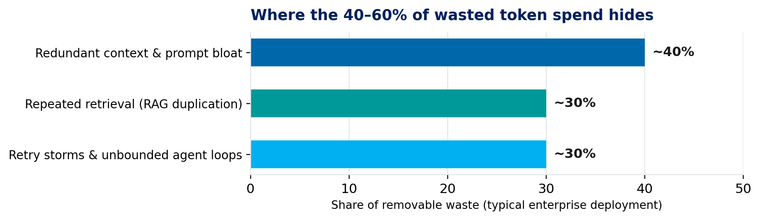
Figure 8 · Anatomy of the 40–60% of token spend that is removable without capability loss.
Failure mode | What happens | Countermeasure
Retry storms | Naive error handling resubmits full contexts on timeouts — multiplying spend precisely when systems are stressed | Exponential backoff; truncated-context retries; circuit breakers
Agent loops without budgets | A stuck agent burns unbounded spend on a single task | Per-task token ceilings; loop limits; context compaction between steps
Model over-provisioning | 100% of traffic routed to the frontier tier when 50–70% of requests are handled equally well by the cheapest tier | Classification + routing with escalation on failure
Reasoning-tier default | Hidden chain-of-thought output is billed but never seen; a single hard query on a top reasoning tier can cost dollars | Reserve reasoning models for tasks that need them
Shadow usage | Unmetered API keys across teams; nobody owns the bill | Central gateway; per-team keys; spend alerts
No unit economics | Nobody can answer "what does one resolved ticket cost in tokens?" | Unit-cost dashboards per feature and use case
Table 13 · The operational failure modes behind runaway bills.

What to watch on the demand side
Agentic consumption, sovereignty rules and maturing procurement will reshape how these bills grow — Section 8.2 takes each in turn.

6. Levers for enterprise cost optimisation
The most effective strategy is almost never "pick the cheapest model." It is to align model quality, traffic pattern and SLA to the cheapest acceptable serving path. The levers below are ordered roughly by effort-to-impact; the prerequisite for all of them is measurement — you cannot optimise what you do not meter.
Lever | Mechanism | Typical saving | Effort
Prompt caching | Structure prompts so static prefixes (system prompt, tool schemas, documents) hit the provider KV cache — ~90% off cached input | 20–50% of input spend | Low
Model routing / cascading | Classify requests; send 50–70% to the cheapest capable tier; escalate on failure; frontier only for the hard 5–15% | 40–60% | Medium
Batch APIs | Route all non-interactive work (documents, ETL, evaluations, reports) to 50%-off async queues | 50% on eligible traffic | Low
Context engineering | Trim prompts, summarise histories, retrieve snippets not documents, cap RAG duplication | 20–40% | Medium
Semantic caching | Serve vector-similar repeat queries from cache (~31% hit rates in enterprise workloads) | 40–70% on FAQ-like traffic | Medium
Agent budgets & guardrails | Per-task token ceilings, loop limits, retry backoff, context compaction | Prevents tail blowouts | Low
Output control | Cap max output tokens, request terse formats, avoid reasoning tiers for routine tasks | 10–30% of output spend | Low
Fine-tuning / distillation | Distill frontier behaviour on your task into a small open model | Up to 10× on that workload | High
Self-hosting open weights | Run distilled/open models on owned or rented GPUs (quantised: AWQ-style 4-bit gives >3× speedup vs FP16) | 50–80% at scale | High
Table 14 · The optimisation playbook. The first five levers routinely deliver 50–70%; 80%+ needs distillation or self-hosting.

6.1 The big three, in practice
Prompt caching is underused because teams optimise prompts for quality, not repetition. On flagship APIs, cached input is ~10% of the standard input rate. If your architecture repeatedly sends the same system prompt, policy block or corpus summary, treat cache-hit rate as a top-level FinOps metric.
Model routing is the highest-leverage single decision because price ladders are steep: mini tiers run at 10–30% of flagship rates. Moving 70% of a flagship workload to a capable mini tier cuts the modelled token bill roughly in half for the same request shapes.
Batch lanes are free money for any workload that can wait: report generation, document processing, evaluations, embeddings refresh. Batch + caching together take effective cost to ~25% of on-demand list price before any deeper engineering.

6.2 Fine-tuning and distillation
Technique | What it showed | Economic consequence
LoRA (2021) | Low-rank adapters cut trainable parameters 10,000× and GPU memory 3× vs full fine-tuning, with no added inference latency | Enterprise customisation becomes a low-cost engineering project, not frontier capex
QLoRA (2023) | A 65B model fine-tuned on a single 48GB GPU in ~24 hours (4-bit quantisation) | Serious tuning fits on one workstation-class GPU — thousands of dollars, not millions
Distillation | A frontier model's behaviour on a narrow task compressed into a small open model | Up to 10× cheaper serving on that workload; the end-game for high-volume routine tasks
Table 15 · Adapter-era customisation. Full fine-tuning is rarely the right default.

6.3 The self-hosting break-even
Rule of thumb
Self-hosting becomes economically rational at roughly $15,000–$20,000 per month of steady API spend on workloads an open model can handle. Below that, engineering and operational overhead exceed the savings.

Favours self-hosting | Favours staying on APIs
High-volume, steady traffic (good batching economics) | Spiky, latency-sensitive traffic (poor utilisation)
Relaxed latency requirements | Capability needs that track the frontier
Data-residency or air-gap requirements add real value | Scarce GPU-operations talent
Narrow tasks a distilled model can absorb | Spend below the ~$15–20K/month threshold
Table 16 · The self-hosting decision. A pragmatic middle path — open-weight models on commodity hosts — captures marginal-cost pricing without operating GPUs, and the portability doubles as negotiating leverage.

The decision compresses into three questions, asked per workload rather than per company — and re-asked quarterly, because every input to it is deflating on a different schedule.
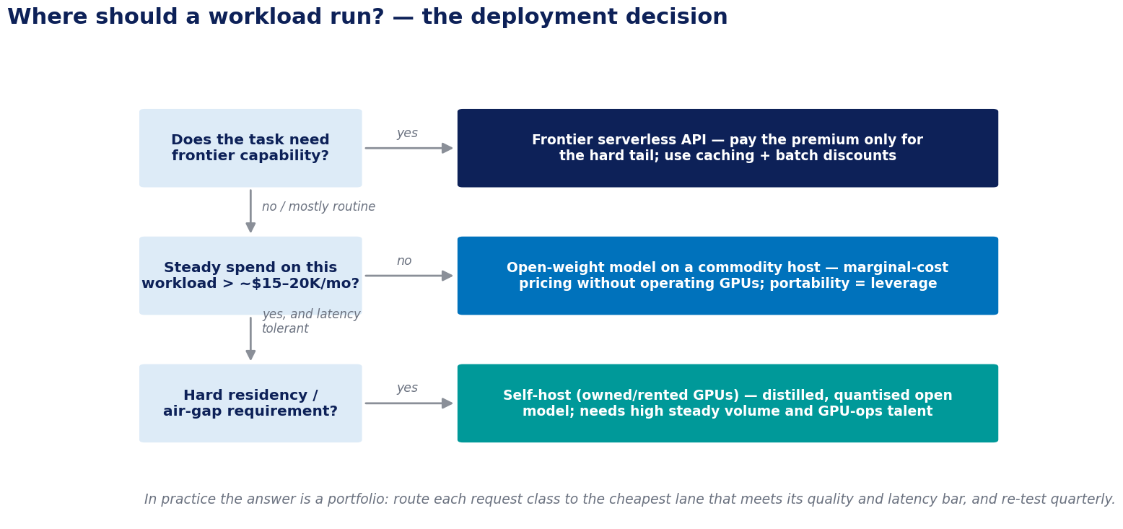
Figure 9 · The deployment decision. Most enterprises end up running all three lanes at once — by policy, not by accident.

7. A FinOps framework for AI in the enterprise
The FinOps Foundation ranks AI cost management as the top forward-looking priority for 2026. The same discipline enterprise IT applied to cloud spend between 2018 and 2022 now applies to tokens — with one difference: at ~10× annual deflation, the review cycle must be quarterly, not annual.
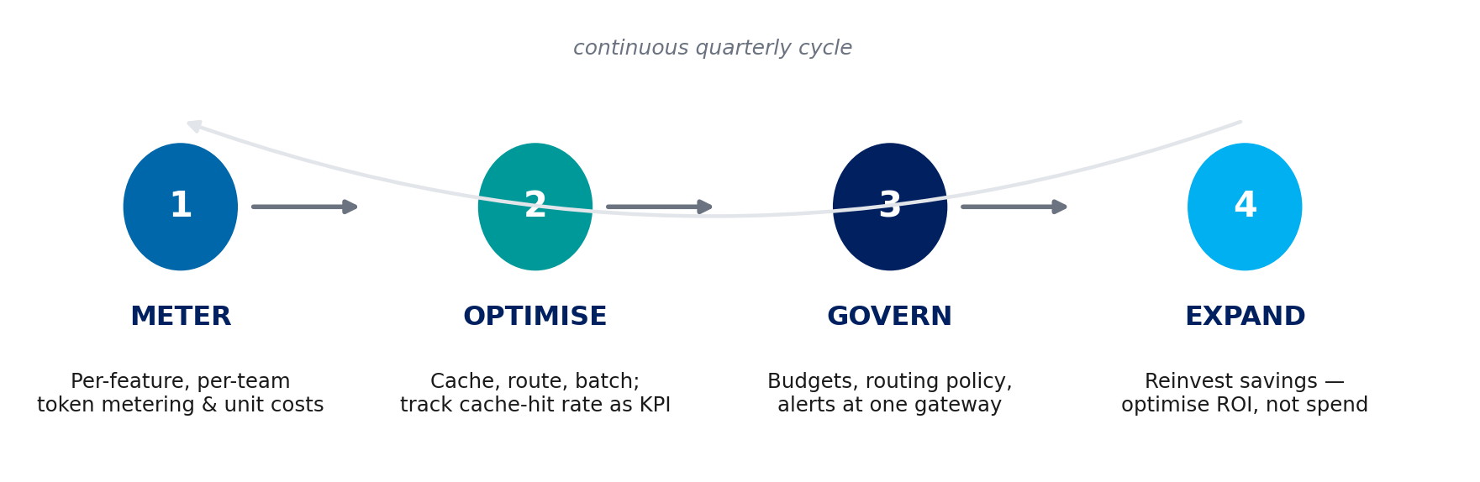
Figure 10 · The operating loop: meter → optimise → govern → expand, refreshed quarterly.

7.1 The four governance moves that matter
1 · One gateway. Centralise API access behind a single gateway that does metering, routing, caching and budget enforcement in one place. This single move eliminates shadow usage and makes every other lever enforceable.
2 · Unit economics. Set cost targets per business outcome — cost per resolved ticket, per document processed, per code change — and make "cost per resolved task" a first-class product metric alongside latency and quality.
3 · Quarterly model reviews. Given ~10× annual deflation, last year's model choice is almost certainly mispriced today. Architectures that abstract the model behind a routing layer capture the deflation automatically; hard-coded single-vendor integrations pay a "model inertia" tax.
4 · Token budgets in design reviews. Make token cost part of feature design review, exactly as cloud cost became part of architecture review a decade ago. Every agent ships with a per-task budget; every feature ships with a unit-cost estimate.

7.2 The metrics that belong on the dashboard
Metric | Definition | Why it matters
Cost per resolved task | Total LLM spend ÷ business outcomes delivered, per use case | The only number that connects spend to value; the anchor for all optimisation
Cache-hit rate | Share of input tokens billed at the cached rate | Directly measures the biggest low-effort discount (~90% off)
Routing mix | Share of requests by model tier (frontier / mid / mini / open) | Detects over-provisioning; target 50–70% on the cheapest capable tier
Batch share | Share of eligible tokens processed through 50%-off async lanes | Free saving on all non-interactive workloads
Output/input ratio | Output tokens ÷ input tokens by feature | Flags verbosity and reasoning-tier misuse (output costs 3–8× input)
Waste indicators | Retry rates, agent-loop overruns, context length percentiles | Early warning on the failure modes of Section 5
Spend vs budget by team | Metered spend per team/key against allocation | Accountability; kills shadow usage
Table 17 · A minimum viable token-FinOps dashboard.

7.3 Tooling and the operating model
None of the governance moves above require building infrastructure from scratch. By 2026 the tooling market has settled into four distinct layers, most with credible open-source options — the build-vs-buy question is mostly a buy (or adopt) question.
Layer | What it does | Representative tools (2026)
AI gateway | Single choke point: metering, routing, caching, budgets, guardrails, audit | LiteLLM, Portkey (Apache-2.0), Kong AI Gateway, Cloudflare AI Gateway, TrueFoundry
Model router / aggregator | One API key across hundreds of models; cheapest-capable selection | OpenRouter, Not Diamond, Martian
Observability & evaluation | Per-request cost attribution, tracing, prompt versioning, quality evals | Helicone, Langfuse, Braintrust
Caching & optimisation | Semantic caching, context compression, agent-side traffic reduction | GPTCache, provider prompt caches, gateway-native caches
Table 18 · The token-FinOps tool stack. The gateway is the non-negotiable layer; the rest attach to it.
The operating model matters more than the tools. The pattern that works mirrors cloud FinOps: a small platform team owns the gateway, the routing policy and the model portfolio; product teams own their unit economics against targets; finance owns budgets, showback and the quarterly review. What differs from cloud is the clock speed — at ~10× annual price deflation and 6–12-month capability half-lives, an annual review cadence guarantees systematic overpayment.
Who | Owns | Cadence
Platform engineering | Gateway, routing policy, caching, model onboarding and exit | Continuous
Product teams | Cost per resolved task, output/input ratio, agent budgets for their features | Per release
Finance / FinOps | Budgets, showback by team and feature, anomaly alerts | Monthly
Architecture review board | Model portfolio refresh, self-host vs API decisions, negotiation strategy | Quarterly
Table 19 · A minimum operating model for token FinOps.

8. Forward-looking trends and implications
The following are extrapolations from observable trends, not certainties; confidence is indicated where it materially varies.

8.1 Supply side: the forces and their trends to 2030
Silicon roadmaps. NVIDIA's Rubin platform (full production early 2026, partner systems H2 2026) claims ~5× inference performance over Blackwell and ~10× lower cost per generated token. More structurally, inference is escaping the general-purpose GPU: custom inference ASICs are projected to grow from ~15% of the inference market in 2024 to ~40% in 2026, hyperscaler in-house silicon is growing ~45% year-on-year against ~16% for merchant GPUs, and specialist architectures have proven the latency frontier — wafer-scale (Cerebras, IPO May 2026) for throughput, LPU-style designs for sub-second first tokens (Groq, whose technology NVIDIA licensed in a $20B deal in late 2025). Cheap-and-slow and expensive-and-instant are diverging into separately priced lanes.
Memory. Decoding is memory-bound, so the memory roadmap is the cost roadmap. HBM4 entered mass production in February 2026: a doubled 2,048-bit interface and >2.8 TB/s per stack directly raise the tokens-per-second ceiling of every serving node. But memory is also the new scarce input — HBM prices rose ~20% for 2026 deliveries, two Korean vendors control ~90% of supply, and the memory share of accelerator bill-of-materials keeps climbing. Expect token-price declines to be gated as much by HBM supply as by GPU launches.
Hardware–model co-design. The frontier of efficiency is no longer hardware or models alone but their joint design: FP4-native weights on Blackwell-class silicon, MoE expert sizes tuned to interconnect topology, speculative decoding pairing small drafter models with large verifiers, and models sized to fit exactly within a node's memory. Each layer compounds — this co-design stack, more than any single chip, is what keeps the deflation curve alive.
Energy and siting. The nuclear PPAs and SMR orders described in Section 3.3 mature over 2027–2035 and will anchor supplier cost structures. At the speculative fringe, orbital data centres — Starcloud's H100-class satellites (first LLM trained in orbit, 2025) and Google's Project Suncatcher TPU prototypes (2027) — chase near-continuous solar power claimed at ~$0.005/kWh. Treat these as directional signals of how central energy has become, not as capacity that will price tokens this decade.
Small, niche and open models. Gartner expects enterprises to use task-specific small models at three times the rate of general-purpose LLMs by 2027. The economics are blunt: a 7B model serves routine agent steps 10–30× cheaper than a 70B+ generalist, and most steps inside deployed agent pipelines are routine. Combined with the continuing cadence of open-weight releases that cap prices at every matched tier, the centre of gravity of token volume shifts toward small, cheap, specialised — with frontier calls reserved for the hard tail.

8.2 Quantifying the supply side: what makes a token 35× cheaper
The forces above are usually asserted, rarely quantified. They can be, because cost per token is a product of independent efficiency terms rather than a sum: silicon, numerics, architecture, software, utilisation and margin each divide the cost of producing a token, and they compound. Taking logarithms turns that product into a sum, which lets each force be assigned a share of the total decline that is order-independent and adds to exactly 100%.
The base case. Applying the driver estimates below, the price of a fixed capability level falls roughly 35× between 2026 and 2030 — about 97% cheaper, consistent with Gartner's projection that trillion-parameter inference costs providers over 90% less in 2030 than in 2025, and with the observed tapering from the ~10×-per-year pace of 2023–25.
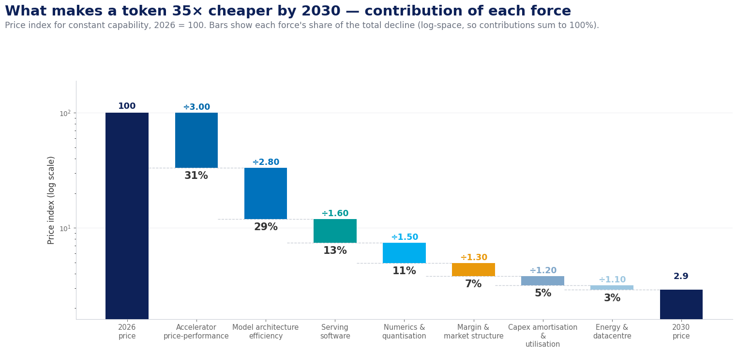
Figure 11 · Decomposition of the 2026–2030 price decline. Contributions are computed in log space and sum to 100%.
Force | Factor | Share | What it measures, and why it is separate
Accelerator price-performance | ÷3.00 | 31% | Rubin-class GPUs and successors; inference ASICs toward ~40% share. Measured as tokens per second per dollar of silicon.
Model architecture efficiency | ÷2.80 | 29% | MoE sparsity, distillation and routing to small models: fewer active parameters per unit of delivered quality.
Serving software | ÷1.60 | 13% | Continuous batching, speculative decoding, disaggregated prefill/decode, prefix reuse.
Numerics & quantisation | ÷1.50 | 11% | FP8 to FP4 and below — fewer bytes moved per parameter per decoded token.
Margin & market structure | ÷1.30 | 7% | Open-weight substitutes compress the markup of price over cost, independent of any cost change.
Capex amortisation & utilisation | ÷1.20 | 5% | Higher achieved fleet utilisation, longer useful life, competition among clouds.
Energy & datacentre | ÷1.10 | 3% | PPAs, nuclear supply and better PUE — net of power scarcity and HBM cost inflation.
Table 20 · The seven supply-side forces, their cumulative 2026–2030 effect, and their contribution to the total decline.
The headline finding. Silicon is not the whole story. Hardware and numerics together account for ~42% of the decline; model architecture and serving software account for another ~42%. In other words, roughly half of the coming price fall is software and model design, not chips — which matters because those gains accrue to whoever builds the models, not only to whoever owns the fabs. Energy, despite dominating the trade press, contributes about 3%: it constrains where capacity can be built, but it is not what makes tokens cheap.
Where the model could be wrong. The two largest terms are also the least certain. If HBM supply stays tight and accelerator price-performance delivers 2× rather than 3×, and architecture yields 1.9× rather than 2.8×, the total decline falls to roughly 10× instead of 35×. Conversely, a genuine ASIC breakout with sub-4-bit numerics could push past 100×. The accompanying model workbook carries both cases through to spend.

A note on method, for the sceptical reader
Two objections are worth pre-empting. First, that architecture and silicon overlap: they do not, because silicon is measured as tokens per second per dollar of hardware while architecture is measured as active parameters per unit of quality — the same token, different denominators. Second, that the ranges should simply be multiplied to give a low case: they should not. Multiplying every driver's pessimistic value assumes the drivers are perfectly correlated, which produces an implausibly wide band. The demand scenarios in Section 8.5 instead scale the total movement, which keeps them coherent.

8.3 Demand side: the forces and their trends to 2030
Consumption becomes machine-dominated. The 24× token-growth forecast to 2030 is an agentic story: pipelines of models calling models, with no human reading most intermediate output. Two second-order effects follow. First, a growing share of demand tolerates latency — agent steps can queue — which shifts volume into batch lanes and improves supplier utilisation. Second, cost per task replaces cost per token as the unit that matters, accelerating the shift to outcome-based pricing.
Sovereignty hardens from preference into procurement rule. The EU AI Act's high-risk obligations become fully applicable in August 2026, with GPAI-model duties already enforceable and fines reaching 7% of global turnover. Regulated buyers have learned the distinction between residency and sovereignty — a Frankfurt data centre run by a US hyperscaler remains subject to the US CLOUD Act — and are provisioning accordingly: Gartner sees European sovereign-cloud infrastructure spend rising from ~$7B in 2025 to $12B+ in 2026. Sovereign deployment costs more per token (regional premiums, smaller batches, duplicated capacity), and open-weight models are its natural substrate: weights you host are weights no foreign statute can recall.
Buyers professionalise. Enterprise AI procurement is acquiring the machinery cloud buying developed a decade ago: committed-use discounts, multi-vendor portfolios behind routing layers, and open-weight price anchors in every negotiation. The FinOps Foundation now ranks AI cost management as its top forward-looking priority — the buy side is organising exactly as the sell side commoditises.
Geopolitics stays priced in. Export controls partition which silicon serves which markets; Chinese open-weight labs keep a global price anchor under every tier regardless; and national AI programmes subsidise regional capacity. The plausible end state is regionally divergent token prices for equivalent capability — an arbitrage that portfolio architectures can capture and single-vendor architectures cannot.
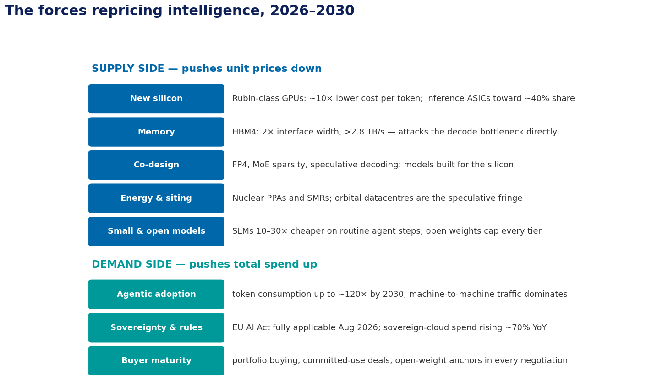
Figure 12 · Supply forces push unit prices down while demand forces push total spend up — the tension that defines tokenomics to 2030.

8.4 Quantifying the demand side: what makes volume 24× larger
The same arithmetic applies to consumption, with one structural difference: five forces multiply demand upward, and a sixth — enterprise optimisation — divides it back down. An earlier version of this model used more upward terms than that, and double-counted adoption as a result.
A correction worth stating openly. An earlier draft of this report cited “120× token growth by 2030” and attributed it to Gartner. Both were wrong. The primary source is Goldman Sachs Research, “AI Agents Forecast to Boost Tech Cash Flow as Usage Soars”, 20 May 2026, which forecasts token consumption multiplying 24×, to 120 quadrillion tokens per month, between 2026 and 2030. The figure 120 is the absolute monthly volume, not the multiplier. The model below is calibrated to the correct 24×.
Why the first version overshot. The earlier model used three separate adoption terms — agentic shift, use-case breadth and adoption depth — and multiplied them, producing 146× gross. That was a methodological error: those three are not independent, they are three descriptions of the same adoption phenomenon, so multiplying them triple-counted it. Supply-side drivers genuinely are independent, because a chip improvement and a quantisation improvement compound cleanly. Demand-side adoption terms are not. The corrected structure uses one penetration term, then per-task intensity terms.
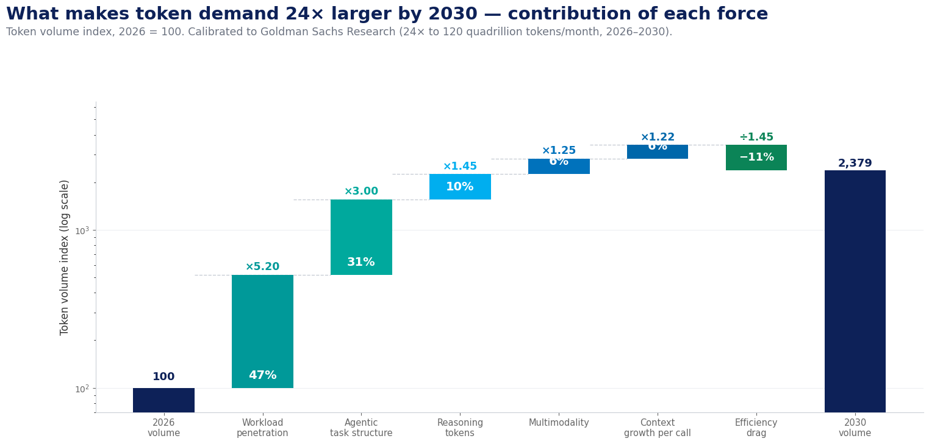
Figure 13 · Decomposition of 2026–2030 token-volume growth, calibrated to Goldman Sachs’ 24× forecast.
Force | Factor | Share | What it measures
Workload penetration | ×5.20 | 47% | Share of business tasks that run on a model at all.
Agentic task structure | ×3.00 | 31% | Tokens per task once a task is agentic: multi-step loops re-sending accumulated context.
Reasoning tokens | ×1.45 | 10% | Hidden chain-of-thought billed per call.
Multimodality | ×1.25 | 6% | Image, audio and video tokens per interaction.
Context growth per call | ×1.22 | 6% | Longer windows, richer retrieval, larger tool payloads.
Efficiency & optimisation drag | ÷1.45 | −11% | Caching, routing to small models, context compression, distillation.
Table 21 · Demand-side forces. Shares are of gross growth; the optimisation drag is shown as an offset.
From gross to net. Gross demand grows roughly 34.5×. Applying an economy-wide optimisation drag of about 1.45× gives net billable growth of 23.8× — within a rounding error of Goldman’s published 24×.
Two things to know about the anchor. First, Goldman built their number bottom-up from simulated use cases — online travel, call-centre handling — and assume only 12% of knowledge workers use agentic AI by 2030, rising to 37% by 2040. That long adoption tail is what keeps the figure at 24× rather than the triple-digit multiples often quoted. Second, their 24× blends consumer and enterprise; they state consumer alone is 12×, which implies the enterprise component grows faster than 24×. For an enterprise audience, 24× is therefore a conservative anchor.

The one number an enterprise controls
Of the six forces, five are market-wide: no single organisation can slow agentic adoption, multimodality or context inflation. Only the optimisation drag is endogenous. An enterprise that pushes its own drag from the market-average 1.45× to 3× — well within reach of caching, routing and compression applied seriously — halves its own token growth while consuming the same intelligence.

8.5 Putting it together: the bill is a choice, not a forecast
Enterprise spend is the product of the two decompositions — but only if the two are measured on the same basis, and this is where most projections go wrong. Multiplying 24× volume growth by the 35× constant-capability price decline implies spend falls by about a third. Multiplying the same 24× by the blended realised price decline of roughly 7× implies spend triples. Both are arithmetically correct. The difference between them is not a forecasting question; it is a decision about whether you keep buying up-tier.
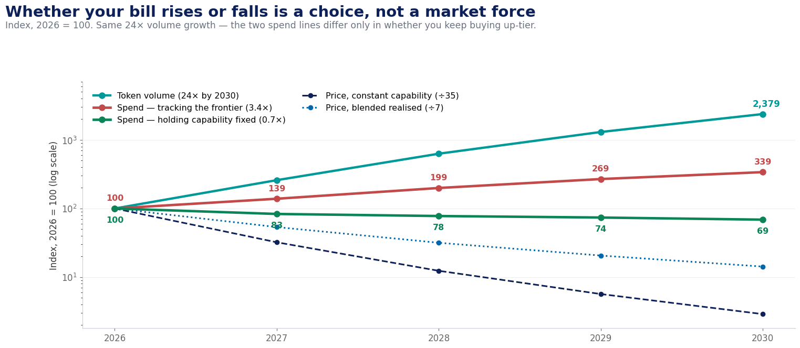
Figure 14 · Identical volume growth; two spend outcomes. The gap between the red and green lines is the up-tier decision.
Year | Price (const. cap.) | Price (blended) | Volume | Spend — hold fixed | Spend — up-tier
2026 | 100.0 | 100.0 | 100 | 100 | 100
2027 | 32.2 | 53.6 | 259 | 83 | 139
2028 | 12.4 | 31.7 | 629 | 78 | 199
2029 | 5.7 | 20.6 | 1,303 | 74 | 269
2030 | 2.9 | 14.2 | 2,379 | 69 | 339
Table 22 · Modelled trajectory, indexed to 2026 = 100.
Why the two price lines diverge. The headline decline applies to a fixed capability level — what today’s quality will cost in 2030. Enterprises do not hold capability fixed: as models improve they move workloads onto better tiers, so their realised average price falls far more slowly. Modelled at roughly 55% of the log decline, the blended realised price falls about 7× rather than 35×. The deflation is real; most enterprises simply spend it on more capability rather than banking it.
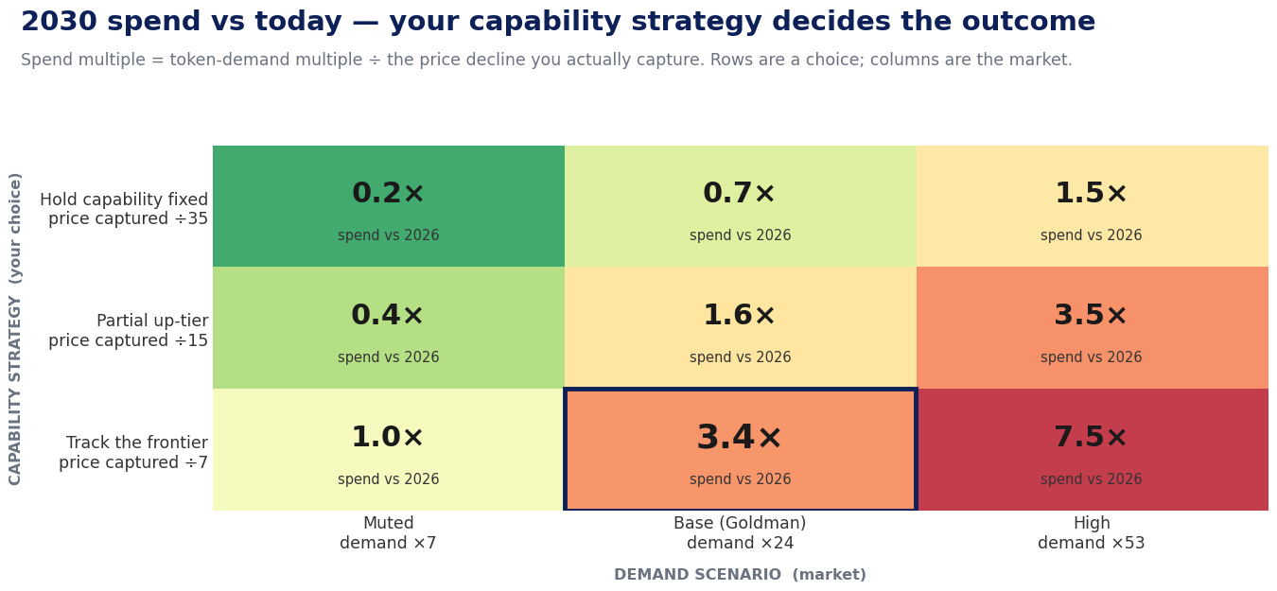
Figure 15 · The rows are a management decision; the columns are the market. Only the rows are within your control.
Capability strategy | Muted demand (×7) | Base — Goldman (×24) | High demand (×53)
Hold capability fixed · captured ÷35 | 0.2× | 0.7× | 1.5×
Partial up-tier · captured ÷15 | 0.4× | 1.6× | 3.5×
Track the frontier · captured ÷7 | 1.0× | 3.4× | 7.5×
Table 23 · 2030 enterprise spend as a multiple of 2026.

The strategic reading
This matrix reframes the entire cost debate. Under the central demand forecast, an enterprise that holds capability fixed sees its bill fall by about a third; one that tracks the frontier sees it triple. Same market, same volume growth, opposite outcomes.
That is not an argument for freezing capability — buying up-tier is often exactly right, because better models complete tasks in fewer attempts and unlock work that was not previously feasible. It is an argument for making the choice deliberately, per workload, instead of discovering it in the invoice. The organisations that lose control of AI spend are not the ones consuming the most intelligence; they are the ones that never decided which tier each workload deserved.

8.6 The trajectory to 2030
Horizon | Expected development | Confidence
2026–27 | Per-capability prices fall ~3× a year, tapering; the mid-market commoditises to near-zero margin as open weights match each tier | High
2027–28 | Pricing-model innovation spreads: outcome- and subscription-based hybrids, priority/provisioned tiers, long-context flat rates as competitive weapons | Medium
2028–29 | Open weights become the default substrate for routine enterprise workloads; frontier APIs reserved for the hard tail | Medium-high
2030 | Trillion-parameter inference costs providers >90% less than in 2025 (Gartner); agentic adoption multiplies token consumption 24×, to ~120 quadrillion tokens/month (Goldman Sachs Research) | Directional
Table 24 · The trajectory to 2030 in four horizons.

8.7 Implications for suppliers
- Unit costs keep collapsing (high confidence). Blackwell-class and successor silicon set successively lower cost floors — $0.02/M tokens is already demonstrated on open 120B models.
- The mid-market commoditises (high confidence). Pure inference hosting converges on utility economics — scale, utilisation and energy decide winners; a business resembling cloud storage or CDN, not software.
- The frontier premium narrows in scope (medium confidence). Pricing power persists only on what open models cannot yet match — agentic reliability, long-horizon tasks, integrated tooling — and revenue shifts toward the application/agent layer, enterprise contracts and provisioned capacity.
- Pricing shifts from tokens to outcomes (medium confidence). Per-token billing erodes toward subscriptions with overages, per-action and per-outcome pricing; raw tokens become the wholesale layer beneath value-priced products.
- Vertical integration intensifies (medium confidence). Custom silicon, owned datacentres and energy procurement become the margin defence for anyone serving at scale.

8.8 Implications for enterprise consumers
- Your bill is a decision, not a forecast (high confidence). At 24× volume growth, holding capability fixed cuts spend by about a third while tracking the frontier triples it. Decide the tier each workload deserves, and manage cost per business outcome rather than total spend.
- Token FinOps becomes permanent (high confidence). Metering, routing, caching and agent budgets become standard platform-engineering functions.
- Model choice becomes a portfolio, refreshed quarterly (high confidence). Any static model selection is mispriced within months; route behind an abstraction layer and capture the deflation automatically.
- Open weights become the default for routine work (medium-high confidence). Frontier APIs for the hard tail; distilled and open models absorb the volume; portability doubles as negotiating leverage.
- The strategic risk inverts (medium confidence). Through 2025 the risk was overspending on AI. From here, the greater risk is under-consuming it: competitors who industrialise agentic workflows convert the same dollar of spend into far more output. Optimisation should fund expansion, not contraction.

The closing thought
Treat tokens as a managed resource: meter, route, cache and batch — then reinvest the savings in scale. The winning enterprise architecture is hybrid and policy-driven: small or open models for high-volume routine work; premium frontier models for hard cases; batch lanes for offline jobs; cached prefixes for repeated corpora; and private or regional deployment only where regulation justifies the uplift.

Appendix A. Glossary
Term | Meaning | Why it matters
Token | A fragment of text, ~4 characters or ~¾ of a word | The unit in which usage is metered and billed
Context window | Everything the model attends to in one call | Re-sent and re-billed on every turn; priced steeply at long lengths
KV cache | GPU memory holding attention state for active sequences | The physical driver of long-context surcharges
Prefill / decode | Parallel prompt pass / sequential token generation | The reason output tokens cost 3–8× input tokens
MFU | Model FLOPs Utilisation — achieved vs peak throughput | 2× MFU ≈ half the compute cost
MoE | Mixture-of-Experts — only a fraction of parameters active per token | Structurally cheaper serving; a key driver of 2025–26 price falls
Quantisation | Reducing weight precision (FP16 → FP8/FP4) | Cuts memory traffic; AWQ-style 4-bit gives >3× serving speedup
LoRA / QLoRA | Adapter-based fine-tuning techniques | Customisation at 1/10,000th of the trainable parameters
Distillation | Compressing a large model's behaviour into a small one | Up to 10× cheaper serving on narrow tasks
Prompt caching | Provider-side reuse of a stable prompt prefix's KV cache | ~90% discount on repeat input
Batch API | Asynchronous, delay-tolerant processing lane | ~50% discount; monetises provider idle capacity
LLMflation | ~10×/year price decline for constant capability | Why model choices must be revisited quarterly
Transformer | The neural architecture behind all current LLMs: stacked layers of attention + feed-forward networks | Its serving profile (memory-bound decode) shapes all token pricing
Attention | Mechanism by which each token reads all previous tokens | Work grows with the square of context length
Embedding | Numeric vector representing a token (or document, for retrieval) | Embedding APIs are metered; vectors feed RAG
Parameters / weights | The learned numbers inside a model (7B–1T+) | Read from memory on every decoded token
FLOPs | Floating-point operations; training needs ≈ 6 × parameters × tokens | The physics of training cost
HBM | High-bandwidth memory stacked next to the GPU die | Its bandwidth caps decode speed; its supply gates price declines
ASIC / LPU | Chips purpose-built for inference rather than general compute | Projected ~40% of inference by 2026; new price floors
Reasoning tokens | Hidden chain-of-thought output billed but not shown | Inflate effective output cost 3–10× on reasoning tiers
Model routing | Classifying requests and sending each to the cheapest capable model | The single highest-leverage optimisation decision
Semantic caching | Serving repeat queries from a similarity-matched answer cache | 40–70% savings on FAQ-like traffic
RAG | Retrieval-augmented generation: fetching documents into the prompt | Bills three times — retrieval, embeddings, and inflated context
Vector database | Store that indexes embeddings for similarity search | Metered per GB and per query; rarely the dominant RAG cost
Agentic workflow | Multi-step loop of plan → tool call → validate → retry | 5–30× the tokens of a chat exchange; context re-sent each step
SLM | Small language model (~1–15B parameters), often task-tuned | 10–30× cheaper than large generalists on routine agent steps
AI gateway | Proxy layer doing metering, routing, caching, budgets in one place | The enforcement point for all token-FinOps policy
PUE | Power Usage Effectiveness: total facility power ÷ IT power | 1.2–1.4 typical; multiplies every watt a GPU draws
Sovereign AI | Deployment under a jurisdiction's legal and technical control | Costs a premium; favours open weights and regional hosts
Speculative decoding | Small model drafts tokens; large model verifies in parallel | 2–3× decode speed-up at equal quality
Continuous batching | Dynamically packing many requests into each forward pass | The main lever behind ~85% marginal-cost reduction
Chinchilla scaling | Compute-optimal ratio of model size to training data | Why training cost is a design choice, not a size choice
Table 21 · Working vocabulary for token economics.

Appendix B. Selected sources
This report synthesises two companion research documents ("LLM Tokenomics and Pricing" and "LLM Tokenomics Report", July 2026) prepared from provider pricing pages and primary literature, cross-checked against public sources including:
- a16z — LLMflation: LLM inference cost trends (a16z.com/llmflation-llm-inference-cost)
- Epoch AI — Inference economics of language models; LLM inference price trends (epoch.ai)
- Gartner — LLM inference cost forecast to 2030 (March 2026 press release)
- NVIDIA — Inference on open models with Blackwell: cost per token (blogs.nvidia.com)
- Provider pricing pages: OpenAI, Anthropic, Google Gemini API, AWS Bedrock, Hugging Face Inference Endpoints, Cohere, DeepInfra, Fireworks AI (accessed July 2026)
- FinOps Foundation — State of FinOps / AI cost management priorities, 2026
- CloudZero, Finout — LLM API pricing comparisons, 2026
- SCMP / InfoWorld — DeepSeek V4 pricing coverage, 2026
- Research literature: Chinchilla (arXiv 2203.15556); LoRA (2106.09685); QLoRA; vLLM (2309.06180); AWQ (2306.00978); inference economics (2506.04645)
- TrendForce — The inference economy: AI chip architecture and ASIC share forecasts, 2026
- SemiAnalysis — Scaling the memory wall: the rise and roadmap of HBM; EE Times — The state of HBM4, CES 2026
- NVIDIA Research — Small language models are the future of agentic AI (arXiv 2506.02153); Gartner — task-specific model adoption forecast
- Google Research — Project Suncatcher: space-based scalable AI infrastructure; CNBC — Starcloud orbital data-centre coverage (Dec 2025)
- Microsoft / Constellation (Three Mile Island PPA), AWS / Talen (Susquehanna PPA) — nuclear power agreements for AI capacity
- European Commission — EU AI Act application timeline; Gartner — European sovereign-cloud spending forecast, 2026
- Braintrust, PointFive — LLM gateway and token-optimisation tool landscape, 2026 (LiteLLM, Portkey, OpenRouter, Helicone, Langfuse)
- Spheron, EcoLogits — inference power consumption and energy-per-token measurements, 2026

Disclaimer: prices cited are public list prices in USD as of mid-2026 and move frequently; negotiated enterprise pricing differs materially. Self-hosted cost figures are first-principles estimates from published hardware specifications and public hourly rates. This document is a point of view, not procurement guidance or financial advice.

Appendix C. Notes and references
Numbered endnotes anchoring specific figures and claims in the text. Prices and market figures are as of mid-2026 and move frequently.

Appenzeller, G., “Welcome to LLMflation”, Andreessen Horowitz (a16z.com/llmflation-llm-inference-cost); Epoch AI, “LLM inference price trends” (epoch.ai/data-insights). Both track price per constant capability, not per flagship model.
CloudZero, State of AI Costs (2026); Finout, LLM API pricing analyses (2026). Enterprise LLM API spend figures are directional market aggregates, not audited totals.
Gartner analyses of agentic workload token consumption (2025–26); corroborated by published production traces of multi-step agent frameworks.
First-principles estimate: 8× H100 node at public cloud rental rates (~$20/hr, 2026) against measured vLLM-class throughput; methodology follows Erdil & Besiroglu (Epoch AI), “Inference economics of language models”, arXiv:2506.04645.
FinOps Foundation, State of FinOps 2026 — AI cost management as top forward-looking priority; enterprise deployment studies of removable token waste.
Provider pricing pages: OpenAI, Anthropic, Google Gemini API, AWS Bedrock, DeepInfra, Together AI, Fireworks AI (all accessed July 2026). Cached input is billed at ~10% of the standard input rate; batch lanes at 50%.
Aggregated production case reports; see also PointFive, “Top token optimization solutions” (2026) and provider optimisation guides.
Gartner, LLM inference cost forecast to 2030, press release, March 2026.
Gartner projection of agentic-AI token consumption to 2030 (~120 quadrillion tokens/month).
OpenAI tokenizer documentation; Anthropic developer documentation. The 4-characters/¾-word figure is an English-language average.
Kwon et al., “Efficient memory management for LLM serving with PagedAttention” (vLLM), arXiv:2309.06180; Epoch AI inference-economics modelling.
Provider pricing pages: OpenAI, Anthropic, Google Gemini API, AWS Bedrock, DeepInfra, Together AI, Fireworks AI (all accessed July 2026). Cached input is billed at ~10% of the standard input rate; batch lanes at 50%.
Provider pricing pages: OpenAI, Anthropic, Google Gemini API, AWS Bedrock, DeepInfra, Together AI, Fireworks AI (all accessed July 2026). Cached input is billed at ~10% of the standard input rate; batch lanes at 50%.
Provider pricing pages: OpenAI, Anthropic, Google Gemini API, AWS Bedrock, DeepInfra, Together AI, Fireworks AI (all accessed July 2026). Cached input is billed at ~10% of the standard input rate; batch lanes at 50%.
Appenzeller, G., “Welcome to LLMflation”, Andreessen Horowitz (a16z.com/llmflation-llm-inference-cost); Epoch AI, “LLM inference price trends” (epoch.ai/data-insights). Both track price per constant capability, not per flagship model.
Appenzeller, G., “Welcome to LLMflation”, Andreessen Horowitz (a16z.com/llmflation-llm-inference-cost); Epoch AI, “LLM inference price trends” (epoch.ai/data-insights). Both track price per constant capability, not per flagship model.
NVIDIA, “Inference cost per token on open models with Blackwell” (blogs.nvidia.com, 2026).
Hoffmann et al., “Training compute-optimal large language models” (Chinchilla), arXiv:2203.15556; the 6ND approximation follows Kaplan et al., arXiv:2001.08361.
Chowdhery et al., “PaLM: Scaling language modeling with Pathways”, arXiv:2204.02311 — reported MFU comparisons across training campaigns.
Google Cloud TPU v4 on-demand list pricing (historical rates); cluster arithmetic in text.
Epoch AI, “Trends in the dollar cost of training frontier AI models” (2024–26); public statements by frontier-lab executives.
Uptime Institute, Global Data Center Survey (2025–26) — industry-average PUE for modern AI facilities.
EcoLogits and Spheron measurements of inference energy per token (2026); Epoch AI, “How much energy does ChatGPT use?” (~0.3 Wh per typical query).
Lawrence Berkeley National Laboratory, “Queued Up” interconnection-queue studies; industry analyses of AI data-centre connection delays (2025–26).
Microsoft–Constellation 20-year PPA for the Three Mile Island Unit 1 restart (announced Sept 2024); AWS–Talen Susquehanna 1.92 GW PPA; Google–Kairos Power SMR agreement (500 MW, 2030–35).
NVIDIA H100 SXM datasheet: 700 W TDP, 3.35 TB/s HBM3 bandwidth.
Kwon et al., “Efficient memory management for LLM serving with PagedAttention” (vLLM), arXiv:2309.06180; Epoch AI inference-economics modelling.
Erdil & Besiroglu (Epoch AI), “Inference economics of language models”, arXiv:2506.04645.
Provider pricing pages: OpenAI, Anthropic, Google Gemini API, AWS Bedrock, DeepInfra, Together AI, Fireworks AI (all accessed July 2026). Cached input is billed at ~10% of the standard input rate; batch lanes at 50%.
Meta Llama Community License — additional licence required above 700 million monthly active users.
SCMP and InfoWorld coverage of DeepSeek V3/R1/V4 API pricing versus Western frontier list prices (2025–26).
CloudZero, State of AI Costs survey (2026): 85% of organisations misestimate AI costs by >10%; 79% report overruns in the trailing twelve months.
Gartner analyses of agentic workload token consumption (2025–26); corroborated by published production traces of multi-step agent frameworks.
Public vector-database pricing (Pinecone serverless calculator and peers, 2026); comparison arithmetic as shown in text.
OpenAI o-series list pricing (o3 $2/$8, o3-pro $20/$80 per 1M tokens, 2026); analyses of hidden reasoning-token billing (TokenMix, 2026).
GPTCache project benchmarks and enterprise workload studies of semantic-cache hit rates.
Lin et al., “AWQ: Activation-aware weight quantization”, arXiv:2306.00978.
Hu et al., “LoRA: Low-rank adaptation of large language models”, arXiv:2106.09685.
Dettmers et al., “QLoRA: Efficient finetuning of quantized LLMs”, arXiv:2305.14314.
Practitioner analyses of self-hosting break-even (2025–26); first-principles arithmetic from GPU rental rates and open-model throughput.
FinOps Foundation, State of FinOps 2026 — AI cost management as top forward-looking priority; enterprise deployment studies of removable token waste.
Portkey gateway open-source (Apache-2.0) announcement, March 2026; Braintrust, “Best LLM gateways” (2026); PointFive tool-landscape guide (2026).
NVIDIA Rubin platform announcements (Computex 2024; full production early 2026); vendor claim of ~10× lower cost per generated token versus Blackwell B200.
TrendForce, “The inference economy arrives: AI chip architecture” (2026) — ASIC share of inference and hyperscaler in-house silicon growth; also HBM pricing analyses (2026).
Silicon Report, “Groq, Cerebras, Tenstorrent: the non-GPU inference bet, one year in” (2026); market coverage of the NVIDIA–Groq licence (Dec 2025) and Cerebras IPO (May 2026).
SK Hynix HBM4 mass-production announcement (Feb 2026); SemiAnalysis, “Scaling the memory wall”; EE Times, “The state of HBM4” (CES 2026).
TrendForce, “The inference economy arrives: AI chip architecture” (2026) — ASIC share of inference and hyperscaler in-house silicon growth; also HBM pricing analyses (2026).
CNBC coverage of Starcloud orbital data centres (Dec 2025), including the ~$0.005/kWh orbital-solar claim; Google Research, “Project Suncatcher” (TPU prototype satellites, 2027). Treat both as early-stage claims.
Gartner forecast: enterprise use of task-specific small models to exceed 3× general-purpose LLM use by 2027.
Belcak et al. (NVIDIA Research), “Small language models are the future of agentic AI”, arXiv:2506.02153.
Goldman Sachs Research, "AI Agents Forecast to Boost Tech Cash Flow as Usage Soars", 20 May 2026 (Jim Schneider): token consumption is forecast to multiply 24×, to 120 quadrillion tokens per month, between 2026 and 2030. Note that 120 is the absolute monthly volume, not the multiplier — an earlier draft of this report conflated the two and mis-attributed the forecast to Gartner. The same article reports inference cost per token falling 60–70% per year, which over 2026–2030 implies a 39–123× decline and corroborates the supply model in Section 8.2.
Regulation (EU) 2024/1689 (EU AI Act): GPAI obligations applicable from Aug 2025; high-risk obligations from 2 Aug 2026; penalties up to €35M or 7% of global turnover.
US Clarifying Lawful Overseas Use of Data (CLOUD) Act, 2018; legal analyses of residency versus sovereignty for AI workloads (2026).
Gartner, European sovereign-cloud IaaS spending forecast (2026).

